ECS Test Drive – Getting started with S3 and Cyberduck
This document is for users who want to establish connectivity to ECS Test Drive via S3 using Cyberduck. Before proceeding, be sure you have registered and can log in to your ECS Test Drive account. Click https://portal.ecstestdrive.com/account/register to complete the registration.
- Once you have registered for you ECS Test Drive account, log in and click the credentials link at the top of the page.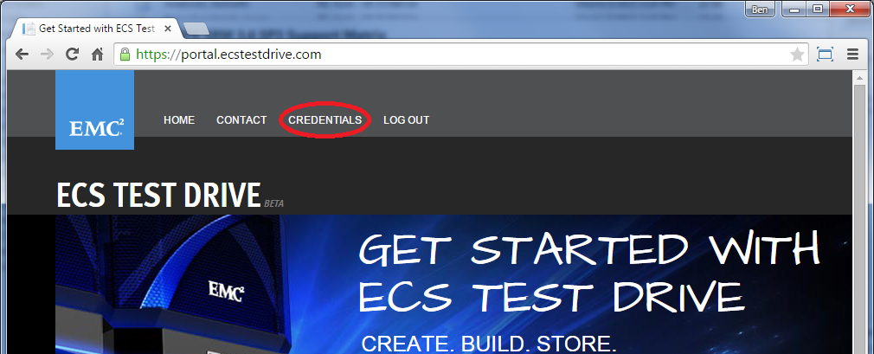
- In the credentials page, click “manage secret keys”. Then, click the “create secret key 1” button.
- Now switch over to cyber and configure a new connection to ECS Test Drive via s3. This is done by clicking the little plus sign in the bottom left corner of the window. 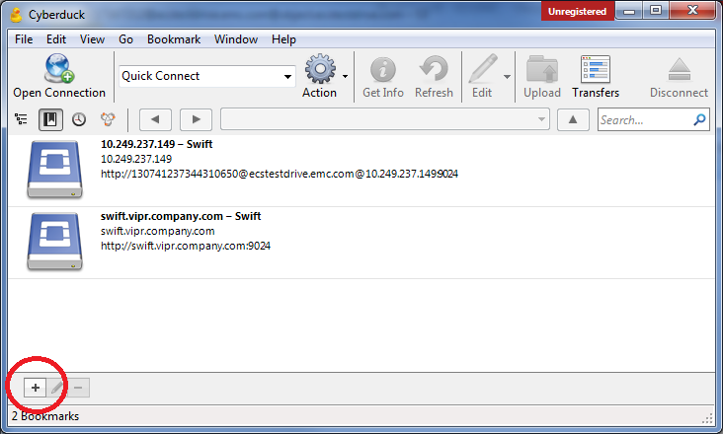
- In the dialog window, choose S3 (Amazon Simple Storage Service) from the first dropdown list.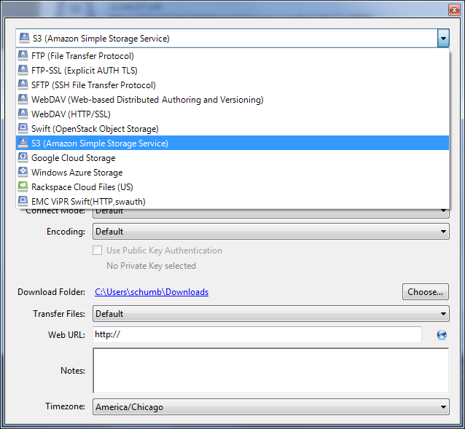
- Using info from your ECS Test Drive credentials page input the Server and Access Key ID. After you finished entering in the information, click the red close button in the top right corner (red circle top left Mac users).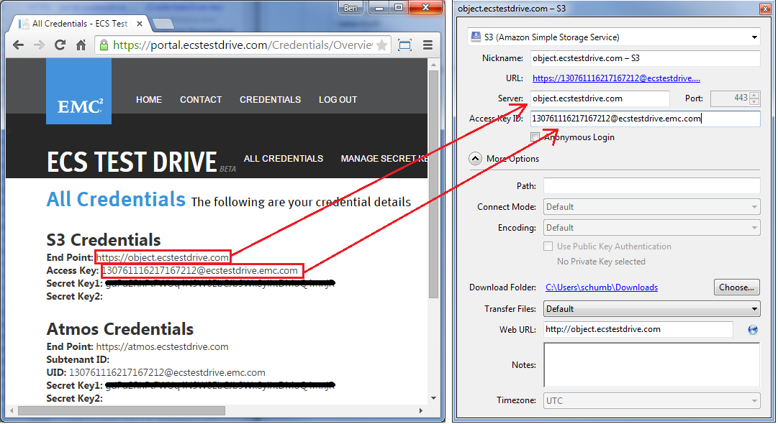
- Double click the new connection that you just configured. You will be prompted for the secret key. Copy and paste the secret from ECS Test Drive into the dialog box and click Login. 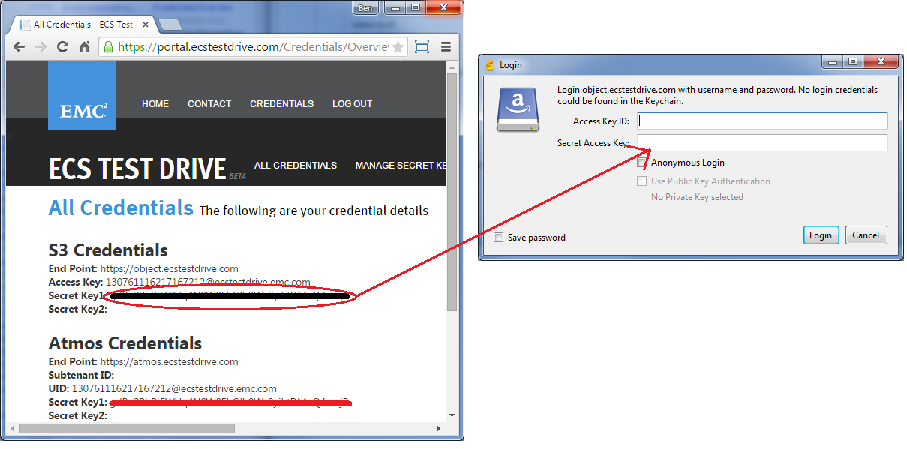
- You are now connected to ECS Test Drive.

